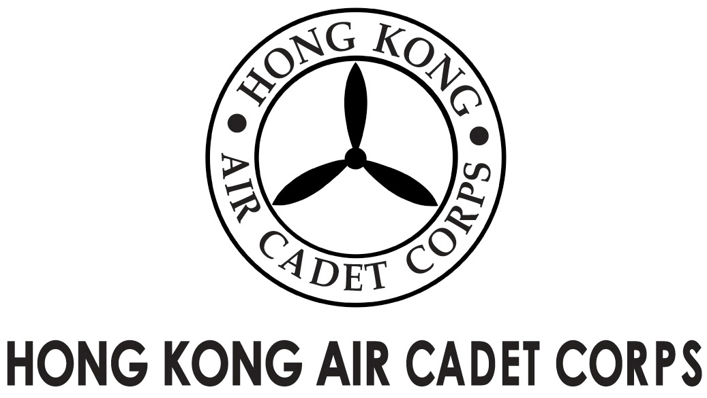
ADMINISTRATION AND SUPPORT GROUP.

From | Adjt A&S Gp / OC PA Flt  (michael@etoileam.com) | To | All major unit commanders
Our Ref | AwardsDay/2015/1 | # of Pages | 1
Date | 16/1/2015 | Your Ref

HKACC Awards Day 2015

HKACC Awards Day will be held on the afternoon of 15th March 2015. Details will be circulated once confirmed. Major unit commanders are reminded to submit their nominations for recognition as soon as possible in view of the time needed for the approval process.

A copy of the “Nomination form 7/2003” is attached for your easy reference. Please contact the undersign at pa@hkacc.info for further enquiries regarding the Awards Day.

(signed on original)

Lisa C H ZHOU
Plt Off Public Affairs Officer
For OC PA Flt

